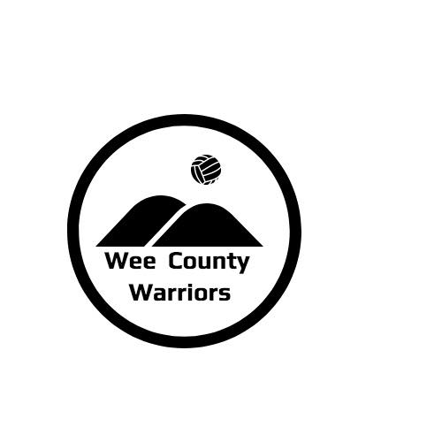

**WEE COUNTY WARRIORS NETBALL CLUB**

**DATA PRIVACY STATEMENT**

We at Wee County Warriors Netball Club want to make sure all the personal information we have collected about you is safe and secure. We will be the “Controller” of the personal data you provide to us. We only collect basic personal data about you this includes name, date of birth, address, email, phone number, photographs and an emergency contact.

We need your basic personal data to administer your membership. We will not collect any information that we do not need to provide this service to you.

**What we use your data for**

The reasons we need to process your data include:

1. Affiliating you with Netball Scotland.
2. Processing your membership form and payments.
3. Sharing personal data with club coaches or officials to administer training sessions or participate in events.
4. Sharing personal data with facility providers to manage access.
5. Sharing personal data with leagues, governing bodies, and other competition providers for entry in events.
6. Analysing club trends.
7. Sending a club survey to improve your experience as a club member.
8. Sharing data with a funding partner as a condition of grant funding.
9. Sharing data with committee members to provide information about club activities, membership renewals or invitation to social events.
10. Sending you club news promoting club activity.
11. Marketing and communications.
12. Sending information about promotions and offers.
13. Sending information about selling club kit, merchandise or fundraising.
14. Sending you flowers, a card or a gift in response to a life event.

**Social media**

The club has Facebook and Twitter social media pages. All members are free to join these social media pages. If you join one of the social media pages, please note that provider of the social media platform(s) have their own privacy policies and that the club do not accept any responsibility or liability for these policies.  Please check these policies before you submit any personal data on the club social media pages.

**How long we keep your data**

We will hold your personal data on file for as long as you are a member with us. Member data is updated every year through membership registration. Any personal data we hold on you will be deleted after 2 years of inactive membership.

**What are your rights**

If at any point you believe the information we hold on you is incorrect you can request to see this information, and have it corrected or deleted. If you wish to raise a complaint on how we have handled your personal data, you can contact us to have the matter investigated.